**Exercise 3: Using Wireshark to understand basic HTTP request/response messages (marked, include in your report)**

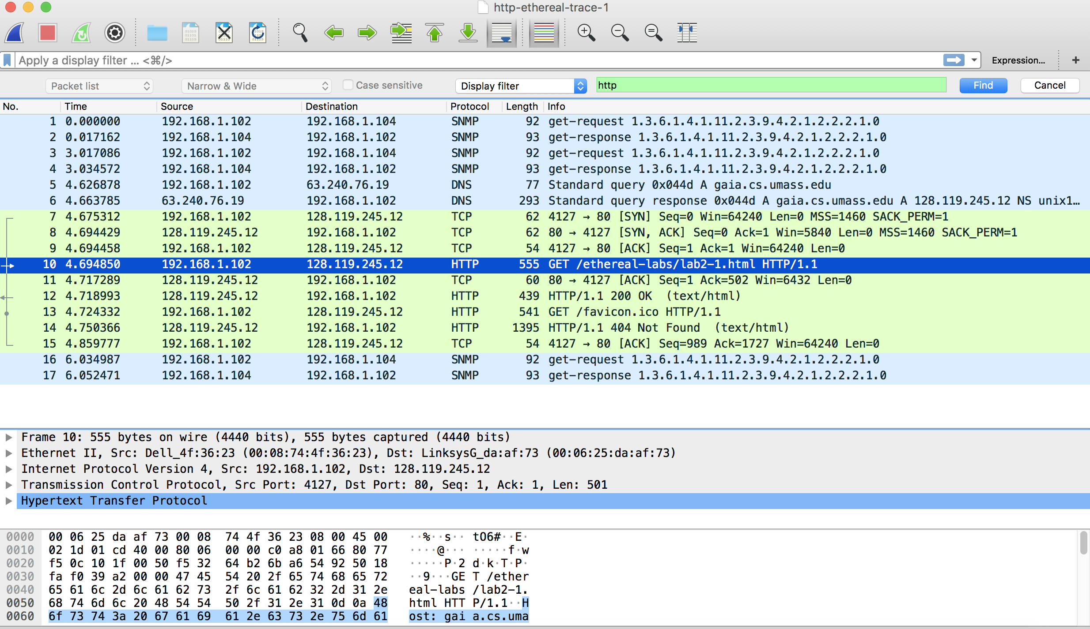

Question 1:

Status Code: 200

Response Phrase: OK

Question 2:

Last-Modified: Tue, 23 Sep 2003 05:29:00 GMT\r\n

It contains a Date header, another date is server’s time.

Question 3:

The connection is persistent, because the connection is keep-alive.

Connection: Keep-Alive\r\n

Keep-Alive: timeout=10, max=100\r\n

Question 4:

Content-Length: 73\r\n

73 bytes

Question 5:

The resources code is:

<html>\n

Congratulations. You’ve downloaded the file lab2.1.html\n

</html>\n

So it will response “ Congratulations. You’ve downloaded the file lab2.1.html” in HTTP response.

**Exercise 4: Using Wireshark to understand the HTTP CONDITIONAL GET/response interaction (marked, include in your report)**

Question 1:

No, both of them do not appear in first request.

Question 2:

Yes, it does, because text returned in response to first GET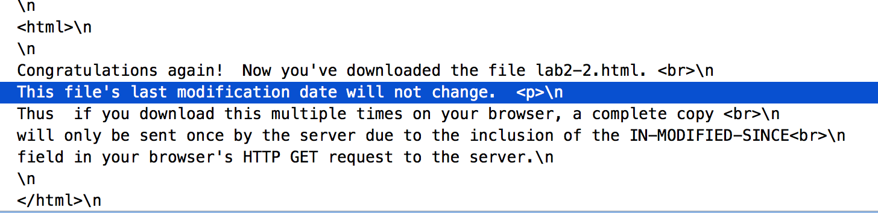

Question 3:

If-Modified-Since: Tue, 23 Sep 2003 05:35:00 GMT\r\n

If-None-Match: “1bfef-173-8f4ae900”\r\n

Question 4:

Status Code:304

Response Phrase: Not Modified

It doesn’t return the contents, because the statues code is 304 which represents the web is not modified last time and it returns empty.

Question 5: What is the value of the Etag field in the 2nd response message and how it is used? Has this value changed since the 1 stresponse message was received?

The value is: ETag: "1bfef-173-8f4ae900"\r\n

ETag can distinguish the resource representation at that URL ever changes, if changed a new and different ETag is assigned.

ETag allows a client to make conditional requests. This allows caches to be more efficient, and saves bandwidth, as a web server does not need to send a full response if the content has not changed.

It doesn’t change since the 1st response message received.